Product ENRICHMENT PORTAL LOG4J Configuration SYSTEM LEVEL

PIM ENHANCEMENT
IT Shared Services

01/21/2016
Version-0.1

Author-Sudha Sharma .

Pim Portal Architect

File Name: | Log4j Configurations System Level | Author / POC: | Sudha Sharma
Version: | 0.1 | Approval Authority: | Ravindra Murthy
Repository: | <link to where document is posted> | Date Approved: | <when SOP is signed / posted to repository>

- VERSION HISTORY -
DATE | VERSION | REVISION DESCRIPTION | Author
01/21/2015 | 0.1 |  | Sudha Sharma

TABLE OF CONTENTS
1 Introduction 5
1.1 Document overview 5
2 Steps to Configure Log4j 6
2.1 Step1 6
2.2 Step2-Configurations on the Portal WAS Console 6
2.3 Step3-Creating Custom Properties 8
2.4 Step4-Configuring Class Loaders 8
Navigate to Application servers > WebSphere_Portal > Class loader 9
2.5 Step4-Restart the Portal Was Server 9
2.6 Step5-Tweaking the Portal Code in Controller and Server Layer 9

Introduction

Document overview
This document describes the LOG4j configurations at System Level
It describes:
- Load the jar files in Portal WAS console
- Log4j.properties config
- Portlet code change to pick up the log 4j configurations

Steps to Configure Log4j

Step1
Checkout the jar files from CA Harvest
Place the the following jar files in the location given below:
PepLogger.jar
log4j-1.2.13.jar

/opt/IBM/WebSphere/wp_profile/com/belk/vp/customlib

Checkout the log4j.properties file from CA Harvest
Place the the following log4j.properties files in the location given below:

/opt/IBM/WebSphere/wp_profile/com/belk/vp/customlib

Screenshot below:
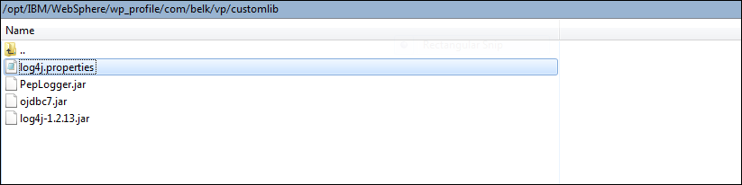

Create the Pep.log file in the following location:
/opt/IBM/WebSphere/wp_profile/com/belk/vp/properties

Screenshot below:

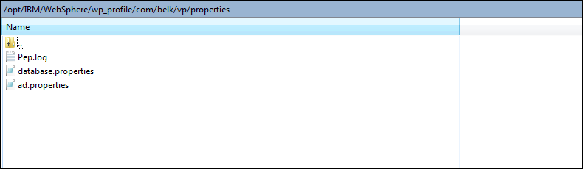

Step2-Configurations on the Portal WAS Console
For Example :
Portal WAS Console Portal WAS Console URL
https://ralpimwsasdv02.belkinc.com:10041/ibm/console/login.do?action=secure
.
Environment->Shared Libraries
Create the shared libraries naming as VP_SHARED_LIB
Give the Path of the custom shared libraries used by the Portal:
/opt/IBM/WebSphere/wp_profile/com/belk/vp/customlib

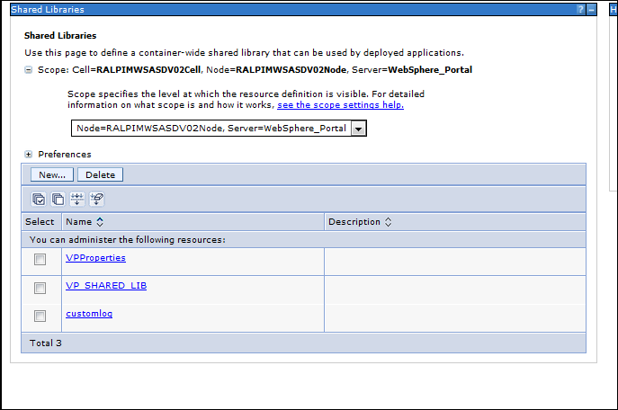

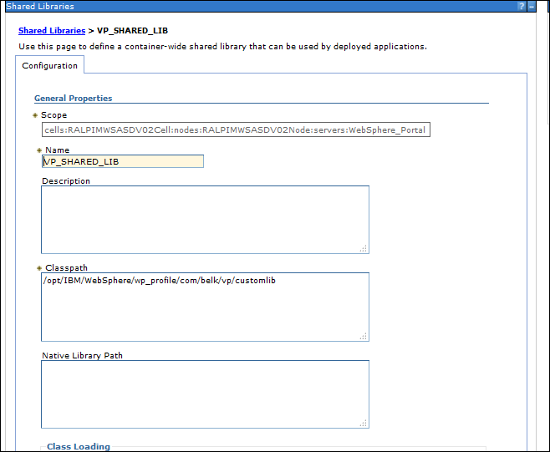

Step3-Creating Custom Properties
Create a new Custom Property by clicking on the New Action Button and By Clicking on Apply

Name- PortalLog
Value- /opt/IBM/Websphere/wp_profile/com/belk/vp/customlib/log4j.properties

Step4-Configuring Class Loaders

Navigate to Application servers > WebSphere_Portal > Class loader

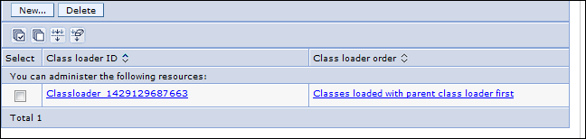

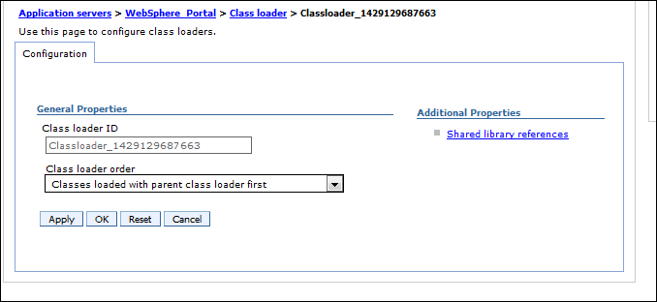

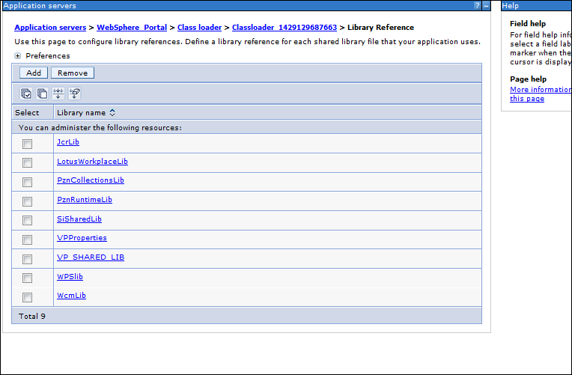

Step4-Restart the Portal Was Server

Step5-Tweaking the Portal Code in Controller and Server Layer

Add the dependency in the pom.xml of the portlet

<dependency>
<groupId>ProductEnrichmentPortal</groupId>
<artifactId>PepLogger</artifactId>
<version>1.0</version>
<scope>provided</scope>
</dependency>

import org.apache.log4j.Logger;

Comment the Java Logger
// private final static Logger LOGGER = Logger
// .getLogger(ContentController.class.getName());
Use the Log4j Logger
final Logger LOGGER = Logger.getLogger(ContentController.class);

Now Log4j is configured,deploy the portlet in portal server,access the portlet and the logs would written to the Pep.log file

